Blood Bank Management
System Project

Sprint Burn Chart

Sprint Burn Chart Details

Sprint 1:
- Planned User Stories: 10
- Completed User Stories: 10
- Cumulative Planned: 10
- Cumulative Completed: 10
- Initial Estimate: 10

Sprint 2:
- Planned User Stories: 10
- Completed User Stories: 9
- Cumulative Planned: 20
- Cumulative Completed: 19
- Initial Estimate: 9

Sprint 3:
- Planned User Stories: 8
- Completed User Stories: 8
- Cumulative Planned: 28
- Cumulative Completed: 27
- Initial Estimate: 8

Interpretation:
- Cumulative Planned: This represents the total number of user stories planned up to each sprint.
- Cumulative Completed: This represents the total number of user stories that were completed up to each sprint.
- Initial Estimate: This is the initial estimated number of user stories planned for each sprint.

Analysis:
- The Sprint Burn Chart shows a steady progression in completing planned user stories across the sprints.
- Sprint 1 achieved all planned user stories, indicating an on-track start.
- Sprint 2 had one user story less completed than planned, suggesting a slight delay or challenge.
- Sprint 3 returned to completing the planned number of user stories, maintaining progress.
This chart provides a snapshot of how the project's development aligned with initial planning over the course of three sprints, highlighting achievements and potential areas for improvement in future sprints.

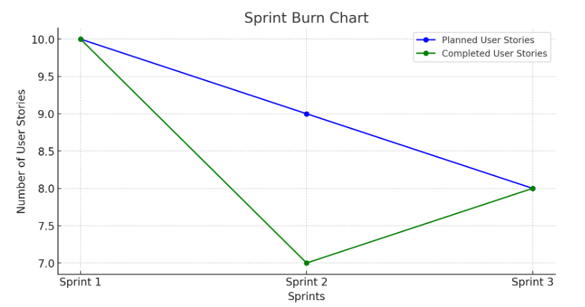

Here's the sprint burn chart based on the sprint velocity and user stories for each sprint in your project. The chart shows the number of planned and completed user stories for Sprints 1, 2, and 3, giving a visual representation of your project's progress.

